
SIGN LANGUAGE FOR DISABLED PEOPLE

A PROJECT REPORT
Submitted by
RAVIKUMAR L (620118106079)
SAILENDRADEVAN V (620118106082)
SIVAKUMAR A (620118106095)
SRI HARI KRISHNAN N (620118106103)

in partial fulfillment for the award of the degree
of
BACHELOR OF ENGINEERING
in
ELECTRONIC AND COMMUBICATION ENGINEERING
AVS ENGINEERING COLLEGE, SALEM

ANNA UNIVERSITY: CHENNAI 600 025
JUNE 2022

ANNA UNIVERSITY: CHENNAI – 600 025

BONAFIDE CERTIFICATE

Certified that the project work entitled ‘‘SIGN LANGUAGE TRANSLATION FOR DISABLED PEOPLE’’ is the bonafide work of Mr. RAVI KUMAR L (620118106079), Mr. SAILENDRADEVAN (620118106082), Mr. SIVAKUMAR A (620118106095), Mr. SRI HARI KRISHNAN (620118106103). who carried out the project work under my supervision

SIGNATURE SIGNATURE

HEAD OFTHEDEPARTMENT SUPERVISOR

Prof. RAMYA R S, M.E., Prof. KANAGARAJ G, M.E, Ph.D
ASSOCIATE PROFESSOR ASSOCIATE PROFESSOR,
Department of ECE, Department of ECE,
AVS Engineering College, AVS Engineering College,
Salem- 636003. Salem- 636003.

Submitted for Project Viva -Voice Examination held on _

INTERNAL EXAMINER EXTERNAL EXAMINER

ACKNOWLEDGEMENT

A great deal of time and effort has been spent in completing this project work. Several people have guided us and contributed significantly to this effort and so this becomes obligate to record our thanks to them.

We express our profound gratitude to our honorable Chairman, Shri. K. KAILASAM, Secretary, Shri. K. RAJAVINAYAKAM, MBA., and also to our Correspondent, Shri. K. SENTHIL KUMAR, B.Tech., for providing all necessary facilities for the successful completion of the project.

We have immense pleasure in expressing our gratitude to our beloved Principal, Dr. A. SRINIVASAN, M.E, Ph.D., for allowing us to have extensive use of our college facilities to do this project.

We have immense pleasure in expressing our gratefulness to our beloved Vice Principal, Dr. R. VISWANATHAN, M.E, Ph.D., for permitting us to use of our college facilities to do our project.

We express our heartiest gratitude to our Head of the Department Prof. R.S. RAMYA, M.E., for her guidance and encouragement.

We indebted to our Project Coordinator Prof. YASODHA DEVI P, M.E, and our project Supervisor Prof. KANAGARAJ G, M.E, (Ph.D.) for his constant help and excellent creative ideas over the period of project work.

We specially thank all our Teaching and Non-Teaching Faculty members of the Department of Electronics and Communication Engineering for their encouragement to do the project work with full interest and enthusiasm. We pay our profound gratitude to the Almighty God for his invisible vigilance and would like to thank our Parents forgiving us support and encouragement.

DECLARATION

We affirm that the Project work entitled “SIGN LANGUAGE TRANSLATION FOR DISABLED PEOPLE” being submitted in partial fulfillment for the award of BACHELOR OF ENGINEERING is the original work carried out by us. It has not formed the part of any other Project work submitted for the award of any degree or diploma, either in this or any other university.

1)
2)

3)
4)

Signature of the Candidate,
RAVIKUMAR L (620118106079)

SAILENDRADEVAN V (620118106082)

SIVAKUMAR A (620118106095)
SRI HARI KRISHNAN N (620118106103)

I certify that the declaration made above by the candidate is true.

Signature of the Guide

Prof. KANAGARAJ G, M.E, (Ph.D.)
ASSOCIATE PROFESSOR,
Department of ECE,
AVS Engineering College,
Salem- 636003.

ABSTRACT

Communication problem between deaf-mute and a normal person have always been a difficult task. The paper illustrates to aid people by means of a glove based deaf-mute communication translator system. The glove is internally fitted out with flex sensor. For each particular movement, the flex sensor produces a proportional change in resistance and measures the emplacement of hand. The processing of these movements is done by Microprocessor. The system includes an action to speech conversion (ATS) block which interprets the matched gestures i.e., action to speech output. Hand gesture is one of the typical methods used in sign language for non-verbal communication. It is most commonly used by deaf and dumb people to communicate among themselves or with normal people. Various sign language systems have been formulated by manufacturers around the world but they are neither adaptable nor cost-effective for the actual users. This paper presents a system prototype that is able to automatically recognize the need of normal people to communicate more effectively with the diminished people. Mute people can’t speak and normal people don’t know the sign language which is used for inter communication between mute people. This system will be useful to solve this problem.

TABLE OF CONTENTS
CHAPTER NO. | TITLE | PAGE NO.
 | ABSTRACT
1 | INTRODUCTION | 1
2 | LITERATURE SURVEY | 2
3 | EXISTING SYSTEM | 6
4 | PROPOSED SYSTEM | 8
 | 4.1 PROPOSED SYSTEM BLOCK DIAGRAM | 9
5 | HARDWARE REQUIREMENTS | 11
 | 5.1 POWER SUPPLY | 12
 | 5.2 TRANSFORMER | 13
 | 5.3 RECTIFIER | 13
 | 5.4 FILTERS | 13
 | 5.5 VOLTAGE REGULATOR | 14
 | 5.6 FLEX SENSOR | 15
 | 5.6.1 FLEX SENSOR OVERVIEW | 16
 | 5.6.2 TYPES OF FLEX SENSOR | 16
 | 5.6.3 CONSTRUCTION | 17
 | 5.6.4 DIRECTION OF USE | 17
 | 5.6.5 HOW FLEX SENSOR WORKS. | 18
 | 5.7 PIC16F887 MICROCONTROLLER | 19
 | 5.8 MP3 MODULE | 28
 | 5.9 SPEAKER | 29
 | 5.10 LCD | 30
 | 5.11 BUZZER | 33
 | 5.12 NODE MCU | 36
6 | SOFTWARE REQUIREMENTS | 38
 | 6.1 PICKit 2 | 38
7 | Conclusion and future enhancement | 42
 | REFERENCE | 43

LIST OF FIGURES
FIGURE NO. | DESCRIPTION | PAGE NO.
3.1 | EXISTING SYSTEM BLOCK DIAGRAM | 6
4.1 | PROPOSED SYSTEM BLOCK DIAGRAM FOR SIGN LANGUAGE | 9
4.2 | PROPOSED SYSTEM BLOCK DIAGRAM FOR EMERGENCY BUZZER | 9
5.1.1 | POWER SUPPLY | 12
5.5 | CIRCUIT DIAGRAM FOR VOLTAGE REGULATION | 14
5.6.1 | FLEX SENSOR | 15
5.6.2 | TYPES OF FLEX SENSOR | 16
5.6.3 | CONSTUCTION OF FLEX SENSOR | 17
5.6.4 | DIRECTION OF USE FOR THE FLEX SENSOR | 17
5.6.5 | WORKING OF AN FLEX SENSOR | 18
5.7.1 | PIN DIAGRAM OF PIC16F884/887 | 19
5.7.2 | PIC16F884/887 OF MICROCONTROLLER | 23
5.7.3 | PIN DIAGRAM OF PIC16F884/887 | 23
5.7.4 | MEMORY REPRESENTATION OF PIC16F884/887 | 24
5.9 | PIN DIAGRAM OF LCD | 32
5.11 | CIRCUIT DIAGRAM FOR BUZZER | 35
5.12 | NODE MCU | 36

LIST OF ABBREVIATIONS

LCD | Liquid Crystal Display
EEPROM | Electrically Erasable Programmable Read Only Memory
PDI | Program and Debug Interface

CHAPTER 1
INTRODUCTION
Humans possess the voice capability for interaction and communication among each other. Unfortunately, not everybody has the capability of speaking and hearing. Sign language used among the community of people who cannot speak or hear as the means of communication. Sign language is a gesture representation that involves simultaneously combining hand shapes, orientation and movement of the hands, arms or body, and facial expressions to express fluently with a speaker’s thoughts. The people who cannot speak makes use of the sign languages to communicate with other fellow vocally impaired person and even with other normal people who knows the meanings of sign languages or an interpreter is needed to translate the meanings of sign languages to other people who can speak and do not know the meanings of sign languages. However, it is not always possible for an individual to be around all the time to interpret the sign languages and not everybody can learn the sign languages. Thus, another alternative is that we can use a computer or a smart phone as a mediator. The computer or a smart phone could take an input from the vocally impaired person and give its textual as well as and audio form of output. Human beings have a natural ability to see, listen and interact with their external environment. Unfortunately, there are some people who are differently abled and do not have the ability to use their senses to the best extent possible. Such people depend on other means of communication like sign language. This presents a major roadblock for people in the deaf and dumb communities when they try to engage in interaction with others, especially in their educational, social and professional environments. Therefore, it is necessary to have an advance gesture recognition or sign language detection system to bridge this communication gap. Sign Language is used by deaf and mute to exchange information between their own community and with other people. Computer recognition of sign language deals from sign gesture acquisition and continues till text/speech generation. Sign gesture can be classified as static and dynamic. However static gesture recognition is simpler than dynamic gesture recognition but both recognition systems are important to the human community. The sign language recognition steps are described.

Sign language is used by deaf and hard hearing people to exchange information between their own community
and with other people. Computer recognition of sign language deals from sign gesture acquisition and continues till
text/speech generation. Sign gestures can be classified as static and dynamic. However static gesture recognition is simpler
than dynamic gesture recognition but both recognition systems are important to the human community. The sign language
recognition steps are described in this survey. The data acquisition, data preprocessing and transformation, feature
extraction, classification and results obtained are examined. Some future directions for research in this area also suggested.

CHAPTER 2
LITREATURE SURVEY

A Literature survey is done to know the existing techniques their significance and limitations. It also includes various proposed technique and their advantages.

Quiapi, Carlis Emmanuel A. and Ramis, Katrina Nicile M.,” Development of a Sign Language Translator Using Simplified Tilt, Flex and Contact Sensor Modules”, 2016 IEEE.
Many researchers have proposed numerous methods for hand gesture recognition systems. Generally, such systems are divided into two basis approaches namely glove − based and vision − based approaches. In glove based analysis, detection of the hand is eliminated by the sensors on the hand and 3D model of the hand is easily subjected to the virtual world and analysis comes next. Such systems are optimal for body motion capture purposes and widely used in industry. On the other hand vision-based analysis are more natural and useful for real time applications.

- Abhinandan Das, Lavish Yadav, Mayank Singhal, Raman Sachan, Hemang Goyal, Keshav Taparia Raghav Gulati, Ankit Singh, Gaurav Trivedi,” Smart Glove for Sign Language Communications”,2016 IEEE.
A healthy human can easily identify a hand gesture, however for a computer to recognize hand gesture first the hand should be detected in the acquired image and recognition of that hand should be done in a similar way as humans do. Yet this is a more challenging approach to implement because of the limitations of such a natural system. The vision-based approaches are carried out by using one or more cameras to capture and analyze 2D or 3D shapes of hands.

[3]. Kalpattu S. abhishek, Lee Chun Fai Qubeley, and Derek Hi,”Glioe-based Hand Gesture Recpgnition sign language Translator Using capacitive T ouch Sensor”, 2016 IEEE.
Detection and gesture analysis of the hands is a growing literature topic and has many user environment limitations for most of the studies. Segmentation of the hand is the first step of such systems. Exceptionally, such systems in and gloves or finger marks have been used to extract the hand posture information in the frame and ease the hand segmentation process by eliminating the varying skin color issue of the problem. This technique allows the system to detect hands in a straightforward manner and it is more robust to change in lightning conditions and it is also independent of the user’s skin color. Another easiness is carried out running the hand gesture recognition system in front of a simple and uniform background like 6 a black curtain.

[4]. Khambaty, Yiusuf & Quintana, Rilandi & Mehdi, Shadaram & Nehal, Sana & Virk, Muneeb & Ahmed, Waqar & Ahmedani, Ghayas. (2008). Cost effective portable system for sign language gesture recognition.
Systems need to distinguish skin color but since background could be estimated easily, it would be very easy to segment the hand region from the background. On the other hand, such systems involving gloves or uniform background ruin the natural behavior of gesture applications by limiting the user environment. Since the scope of the thesis is detecting hands in a complex background and since the hand has no strict shape that can be easily identified in an image, system is calibrated by using face color information. Face has a strict shape and detection of face is much more straightforward. Consequently, one can say that the hand detection is based on a face detection algorithm. Face detection methods can be categorized into 3 main sections: Feature Invariant Methods, Template Matching Methods and Appearance.Feature invariant methods are capable of localizing faces in an image even if pose, viewpoint or lightning conditions vary. Template matching methods are based on storing several standard patterns of the face and correlating them with the current input image to detect faces. Lastly, appearancebased methods (in contrast to template matching) face patterns are learned from a set of training images which include representative variability of facial appearance.

[5]. M. G. Kumar, M. K. Gurjar, and M. S. Singh, "American sign language translating glove using flex sensor," Imperial Journal of Interdisciplinary Research, vol. 2, no. 6, 2016.
Sign language is a very organized and highly developed nonverbal language which utilizes both hand gestures and facial expressions to convey the essence of what an individual is trying to say. This is quite a challenge as knowledge of sign language is known to people in very limited circles, usually family members of the deaf and mute community. Not every person can understand and comprehend sign language-based communication. As a solution to this problem, a sign language recognition system is implemented in this paper, which could assist differently abled people in their daily lives by translation their gesture into meaningful English letters and words.

CHAPTER 3
EXISTING METHOD
It is based on the need of developing an electronic device that can translate sign language in order to make the communication take place between the mute communities with the general public possible. A wireless data gloves is used in which is normal clothes diving gloves fitted with flex sensors along the length of each finger. Sign language is a very organized and highly developed nonverbal language which utilizes both hand gestures and facial expressions to convey the essence of what an individual is trying to say. This is quite a challenge as knowledge of sign language is known to people in very limited circles, usually family members of the deaf and mute community. Not every person can understand and comprehend sign language-based communication. As a solution to this problem, a sign language recognition system is implemented in this paper, which could assist differently abled people in their daily lives by translating their gestures into meaningful English letters and words. Must people can use the gloves to perform hand gesture and it will be converted into speech so that normal people can understand their expression. A gesture in a sign language is a particular movement of the hands with a specific shape made out of them. Speech-impaired and hearing-impaired people only have the sign language as their principal means of communication. However, this becomes problematic to people who are not familiar with the different gestures of the sign language, thus creating a communication barrier between the impaired and not. Sign language doesn’t use acoustic sounds but visually transmitted sign patterns. By simultaneously combining hand shapes, orientation, movement, and facial expressions, this can be used to express the speaker’s thoughts and it carries as much information as any spoken language. The availability of sign language translators based on the ASL has already been developed and/or researched by various scholars globally. Despite these, there hasn’t been a solid and concrete process in which the translation is from text or speech to the ASL gestures thus suggesting a one-sided approach on the matter.
One million people worldwide severely lack the ability to hear or speak. Due to learning disabilities, they are often not able to communicate with the general public through conventional means, thus resorting to the use of sign languages. As the Majority of healthy people have little or no understanding of sign languages, it is a challenge for the deaf and mute to effectively communicate with the people they meet throughout their daily lives. It is reported that 5% of world population consists of deaf and mute and hard hearing people. They used some kind of Hand, head and gesture to share their feeling and Ideas to the other peosons. The development of the sign language is to solve the problem of the message sharing to the other person. The most dominating research going on the this sign language to minimize the effects and make simple as to use. The reason is that large number of standard databases for Hand gesture are available publicly. Sign language translators that are commercially available are typically limited in portability. The sophistication employed in detecting hand gestures required heavy computations and associated energy storage rendering these devices expensive and bulky unsuitable of in-field applications. Several major demonstrations of the sign language recognition devices have been reported. Early gesture recognition devices operate through image recognition, which have suffered from poor accuracy.

FLEX SESNSOR

A to D
Converter

MICRO CONTROLLER

VOICE PROCESSOR

Fig 3.1: Existing system block diagram

The incorporation of flex sensors serves mainly to differentiate between many gestures that involve a certain ‘degree of bend’ of their fingers. The flex sensor is used to develop to track the movement of the fingers of user’s hand. The data gloves collects the information of maximum and the minimum value of the flex sensor of each and it calculate the angle of the according the value of the flex sensor that we already uploaded in the device based on that information the message will display and the speaker will announce the information to other persons. The purpose of this research is to allow the young children to interact within a VR space in class room. This method can be applied effectively to reduce the error in finger tracking. We believe that using these gloves will enable young children to use an optimized data glove in their own hands easily. However, there are many technical are many technical problems, such as difficulty in tracking the thumb, so we need more investigation on this method. These sensors, which determine gestures based on the resistance of the flex sensor strip. The sensor incorporates flex sensors mounted atop each finger. As the flex sensors are bent, the resistance across the sensor changes. The sensor achieved low hardware complexity. However, as each user has a slightly different geometry, consistency across users is difficult to maintain.

Limitations of Existing system
- This system has only one way translator (only voice as their output).
- It needs a person always nearby.
- It has only limited Storage.

CHAPTER 4
PROPOSED SYSTEM

To develop a wearable device based on the state-of-art technology to recognize the various hand gestures to assist the speech impaired people and also targeting deaf people. These people can communicate digitally using the flex sensor. The system should be made user friendly, wearable, light weight, configurable, highly responsive, capable of providing real-time outputs, rugged and viable. The purpose of this system is to be a wearable, multi-node data capture and gesture recognition system for the people suffering from speech disorders and patients lying disabled. So as per the demand, the system design purposes are primarily low power, high bandwidth communications, small size and lightweight realization, with the precept that the data captured be enough to distinguish gestures. High bandwidth communications is needed to assure that many nodes can transfer their data simultaneously, facilitating a real time system response. Small and lightweight system is required to make the device wearable so that it does not hinder the normal activity of the wearer. Low power is required to give the device a ample battery life with a small and therefore lightweight battery. This sensing unit consists of flex sensors, signal conditioning unit, high performance processor, wired communication link, power source and wearable platform. Sensor used for this project is a flex sensor.

Advantage of proposed system

- It is less in weight.
- It is easy to access.
- It is cost economical.

4.1 PROPOSED SYSTEM BLOCK DIAGRAM

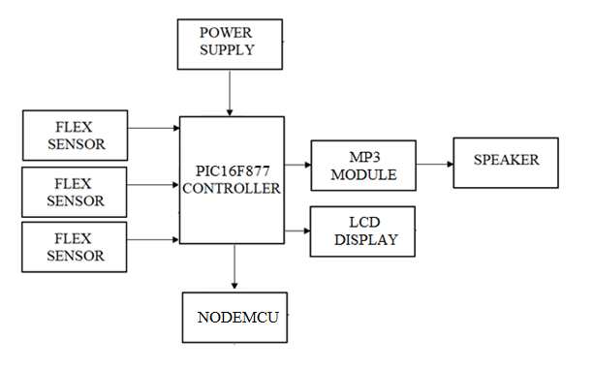
Fig 4.1: Proposed system block diagram for Sign language

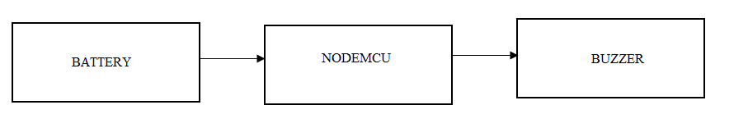
Fig 4.2: Proposed system block diagram for Emergency Buzzer

4.2 PROPOSED SYSTEM BLOCK DIAGRAM EXPLAINATION
The flow process of system is shown in Fig. When power on the system, then first of all the non-verbal communication is given to the system through the flex sensors. There the 3-flex detector, which will be operated with +5v as by giving the actual hand gesture, the resistance variance happens in flex detector by that the output analog signal is made. Analog output is given to the analog pins of microcontroller. 16*2 LCD display is connected to the microcontroller. MP3 module is fixed with the microcontroller, based upon the gesture of flex sensor changes automatically 7 different voices will be played through speaker. Program is written through Embedded C and with the help of PIC C compiler. The coding file is converted into hex file and loaded into the empty IC with the help of PICKIT2 Loader. If the person gives emergency signal, buzzer will be alarmed through wireless communication within certain distance.

The given block diagram includes following:
Transformer: A transformer is an electromagnetic static device, which transfers electrical energy from one circuit to another, either at the same voltage or at different voltage but at the same frequency.
Rectifier: The function of the rectifier is to convert AC to DC current or voltage. Usually in the rectifier circuit full wave bridge rectifier is used.
Filters: The Filter is used to remove the pulsated AC. A filter circuit uses capacitor and inductor. The function of the capacitor is to block the DC voltage and bypass the AC voltage. The function of the inductor is to block the AC voltage and bypass the DC voltage.
Voltage Regulator: Voltage regulator constitutes an indispensable part of the power supply section of any electronic systems. The main advantage of the regulator ICs is that it regulates or maintains the output constant, in spite of the variation in the input supply.
4.3 LCD
A liquid crystal display (LCD) is a thin, flat display device made up of any number of color or monochrome pixels arrayed in front of a light source or reflector. Each pixel consists of a column of liquid crystal molecules suspended between two transparent electrodes, and two polarizing filters, the axes of polarity of which are perpendicular to each other. Without the liquid crystals between them, light passing through one would be blocked by the other. The liquid crystal twists the polarization of light entering one filter to allow it to pass through the other.

Fig 4.3: Pin Diagram of LCD
4.4 NODE MCU

The ESP8266 WiFi Module is a self-contained SOC with integrated TCP/IP protocol stack that can give any microcontroller access to your WiFi network. The ESP8266 is capable of either hosting an application or offloading all WiFi networking functions from another application processor. Each ESP8266 module comes pre-programmed with an AT command set firmware, meaning, you can simply hook this up to your Arduino device and get about as much WiFi-ability as a WiFi Shield offers (and that's just out of the box) The ESP8266 module is an extremely cost-effective board with a huge, and ever growing, community. This module has a powerful enough on-board processing and storage capability that allows it to be integrated with the sensors and other application specific devices through its GPIOs with minimal development up-front and minimal loading during runtime. Its high degree of on-chip integration allows for minimal external circuitry, including the front-end module, is designed to occupy minimal PCB area.

CHAPTER 5
HARDWARE REQUIREMENT

- Power Supply
- Transformer
- Rectifier
- Filters
- Voltage Regulator
- Flex Sesnsor
- PIC16F887 Microcontroller
- MP3 Module
- Speaker
- LCD
- Buzzer.

5.1 POWER SUPPLY
Definition:
A power supply (sometimes known as a power supply unit or PSU) is a device or system that supplies electrical or other types of energy to an output load or group of loads. The term is most commonly applied to electrical energy supplies, less often to mechanical ones, and rarely to others.
5.1.1. POWER SUPPLY UNIT BLOCK
All digital circuits work only with low DC voltage. A power supply unit is required to provide the appropriate voltage supply. This unit consists of transformer, rectifier, filter and a regulator. AC voltage typically of 230Vrms is connected to a transformer which steps that AC voltage down to the desired AC voltage level. A diode rectifier then provides a full wave rectified voltage that is initially filtered by a simple capacitor filter to produce a DC voltage. This resulting DC voltage usually has some ripple or AC voltage variations. Regulator circuit can use this DC input to provide DC voltage that not only has much less ripple voltage but also remains in the same DC value, even when the DC voltage varies, or the load connected to the output DC voltage changes. The required DC supply is obtained from the available AC supply after rectification, filtration and regulation. Block diagram of power supply unit is shown in Figure.
FILTER
RECTIFIER
AC SUPPLY
TRANSFORMER

DC SUPPLY
VOLTAGE
REGULATOR

Fig 5.1.1: Power Supply

The main components used in the power supply unit are Transformer, Rectifier, Filter and Regulator. The 230V AC supply is converted into 9V AC supply through the transformer. The output of the transformer has the same frequency as in the input AC power. This AC power is converted into DC power through diodes. Here the bridge diode is used to convert AC supply to the DC power supply. This converted DC power supply has the ripple content and for normal operation of the circuit, the ripple content of the DC power supply should be as low as possible. Because the ripple content of the power supply will reduce the life of the circuit. So to reduce the ripple content of the DC power supply, the large value of capacitance filter is used.
This filtered output will not be the regulated voltage. For this purpose IC7805 regulator IC is used in the circuit.

5.2 TRANSFORMER
Transformer is a device used either for stepping-up or stepping-down the AC supply voltage with a corresponding decreases or increases in the current. Here, a transformer is used for stepping-down the voltage so as to get a voltage that can be regulated to get a constant 5V.
5.3 RECTIFIER
A rectifier is a device like semiconductor, capable of converting sinusoidal input waveform units into a unidirectional waveform, with a nonzero average component.
5.4 FILTERS
Capacitors are used as filters in the power supply unit. The action of the system depends upon the fact, that the capacitors stores energy during the conduction period and delivers this energy to the load during the inverse or non-conducting period. In this way, time during which the current passes through the load is prolonged and ripple is considerably reduced.
5.5 VOLTAGE REGULATOR
The LM78XX is three terminal regulator available with several fixed output voltages making them useful in a wide range of applications. IC7805 is a fixed voltage regulators used in this circuit. Circuit diagram of such power supply.
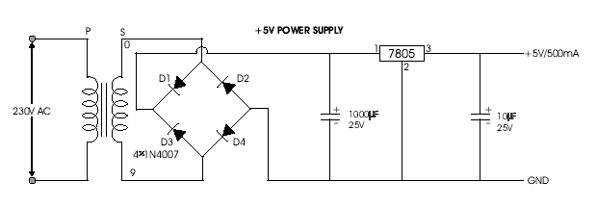
Fig 5.5: Circuit diagram for Voltage Regulation

Features:-
- Excellent Quality
- Short Circuit, Over Voltage & Over Current Protection
- Incredibly Low Fault Rates
- No Minimum Load
- This power supply is a regulated Center Positive power supply
- It's plug design is for Indian power socket so, no plug converter is required
- Compact size & light weight
- High Reliability
- Regulated Stable Voltage
- Good quality SMPS Based Adapter
- Stabilized Output, low ripple & low interference
- Single Output Voltage
- High Efficiency & low energy consumption
Specifications:-
- Input - 100-240 VAC 50/60Hz
- Category - Switch Mode Power Adaptor (SMPS)
- Output Type - DC
- Output - 5Volts 1Amp
5.6 FLEX SENSOR
A flex sensor or bend sensor is a low-cost and easy-to-use sensor specifically designed to measure the amount of deflection or bending.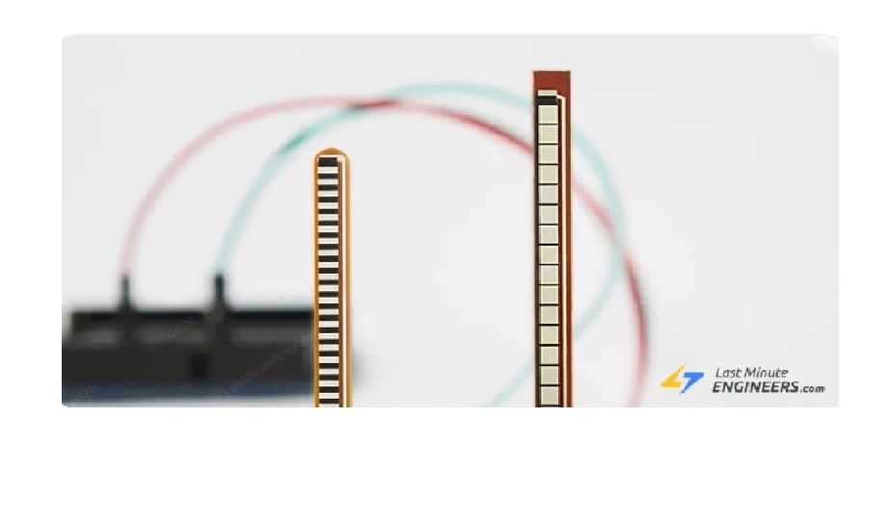 Fig 5.6: Flex Sensor
It became popular in the 90s due to its use in the Nintendo Power Glove as a gaming interface. Since then people have been using it as a goniometer to determine joint movement, a door sensor, a bumper switch for wall detection or a pressure sensor on robotic grippers.
5.6.1 FLEX SENSOR OVERVIEW
A flex sensor is basically a variable resistor that varies in resistance upon bending. Since the resistance is directly proportional to the amount of bending, it is often called a Flexible Potentiometer.

5.6.2 TYPES of FLEX SENSOR:
The flex sensor has been classified has two types of size they are.
- 2.2″ (5.588cm) long,
- 4.5″ (11.43cm) long.
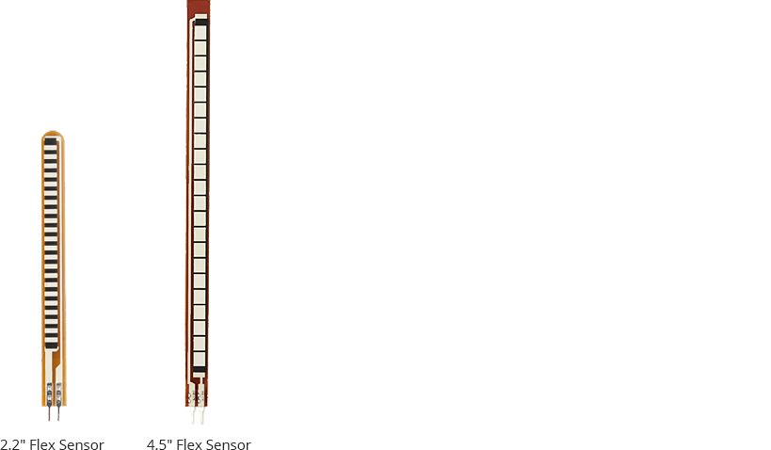
Fig 5.6.2: Types Flex Sensor

5.6.3 CONSTRUCTION:
A flex sensor consists of a phenolic resin substrate with conductive ink deposited. A segmented conductor is placed on top to form a flexible potentiometer in which resistance changes upon deflection
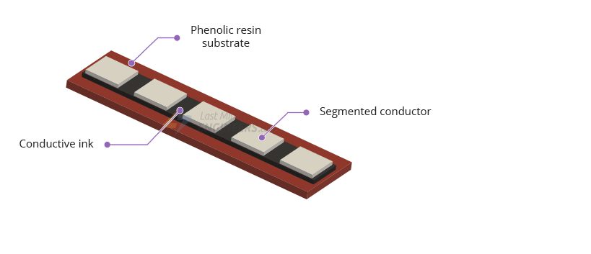
Fig 5.6.3: Construction of Flex Sensor

5.6.4 DIRECTION OF USE:
Flex sensors are designed to flex in only one direction – away from ink (as shown in the figure). Bending the sensor in another direction may damage it.
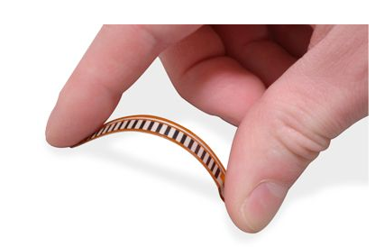
Fig 5.6.4: Direction of use for the Flex Sensor

Also take care not to bend the sensor close to the base, because the bottom of the sensor (where the pins are crimped on) is very fragile and can break when bent over.

5.6.5 HOW FLEX SENSOR WORKS?
The conductive ink printed on the sensor acts as a resistor. When the sensor is straight, this resistance is about 25k.
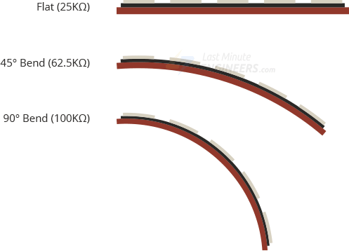
Fig 5.6.5: Working of an Flex Sensor

When the sensor is bent, conductive layer is stretched, resulting in reduced cross section (imagine stretching a rubber band). This reduced cross section results in an increased resistance. At 90° angle, this resistance is about 100KΩ.
When the sensor is straightened again, the resistance returns to its original value. By measuring the resistance, you can determine how much the sensor is bent.

5.7 PIC16F887 MICROCONTROLLER

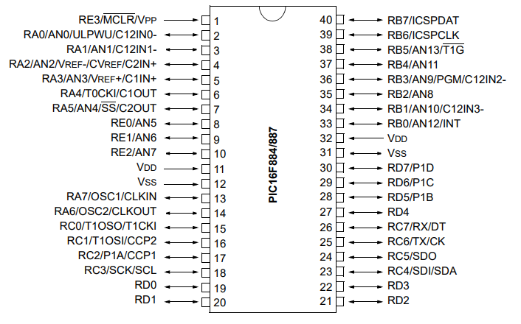
Fig 5.7.1: PIN Diagram of PIC16F884/887

In this project we are using a PIC Microcontroller i.e. PIC16F877 which is a 40 pin Microcontroller.PIC Controller needs a +5 Volt VCC supply voltage. It has an in built ADC (Analog to Digital Converter) which is a 10-bit and 8 914 | P a g e Channel. The output from the Flex Detector is given to that internal ADC also the output from Accelerometer is also given to the ADC to convert that analog Voltage value into Digital Ascii code.
Features
• 2 PWM 10-bit
• 256 Bytes EEPROM data memory
• ICD
• 25mA sink/source per I/O
• Self-Programming
• Parallel Slave Port
This powerful yet easy-to-program (only 35 single word instructions) CMOS FLASH-based 8-bit microcontroller packs Microchip's powerful PIC® architecture into an 40- or 44-pin package.The PIC16F887 features 256 bytes of EEPROM data memory, self programming, an ICD, 2 Comparators, 14 channels of 10-bit Analog-to-Digital (A/D) converter, 1 capture/compare/PWM and 1 Enhanced capture/compare/PWM functions, a synchronous serial port that can be configured as either 3-wire Serial Peripheral Interface (SPI™) or the 2-wire Inter-Integrated Circuit (I²C™) bus and an Enhanced Universal Asynchronous Receiver Transmitter (EUSART). All of these features make it ideal for more advanced level A/D applications in automotive, industrial, appliances or consumer applications.
The PIC16F887 is one of the latest products from Microchip. It features all the components which modern microcontrollers normally have. For its low price, wide range of application, high quality and easy availability, it is an ideal solution in applications such as: the control of different processes in industry, machine control devices, measurement of different values etc. Some of its main features are listed below.
- RISC architecture
  - Only 35 instructions to learn
  - All single-cycle instructions except branches
- Operating frequency 0-20 MHz
- Precision internal oscillator
  - Factory calibrated
  - Software selectable frequency range of 8MHz to 31KHz
- Power supply voltage 2.0-5.5V
  - Consumption: 220uA (2.0V, 4MHz), 11uA (2.0 V, 32 KHz) 50nA (stand-by mode)
- Power-Saving Sleep Mode
- Brown-out Reset (BOR) with software control option
- 35 input/output pins
  - High current source/sink for direct LED drive
  - software and individually programmable pull-up resistor
  - Interrupt-on-Change pin
- 8K ROM memory in FLASH technology
  - Chip can be reprogrammed up to 100.000 times
- In-Circuit Serial Programming Option
  - Chip can be programmed even embedded in the target device
- 256 bytes EEPROM memory
  - Data can be written more than 1.000.000 times
- 368 bytes RAM memory
- A/D converter:
  - 14-channels
  - 10-bit resolution
- 3 independent timers/counters
- Watch-dog timer
- Analogue comparator module with
  - Two analogue comparators
  - Fixed voltage reference (0.6V)
  - Programmable on-chip voltage reference
- PWM output steering control
- Enhanced USART module
  - Supports RS-485, RS-232 and LIN2.0
  - Auto-Baud Detect
- Master Synchronous Serial Port (MSSP)
  - supports SPI and I2C mode
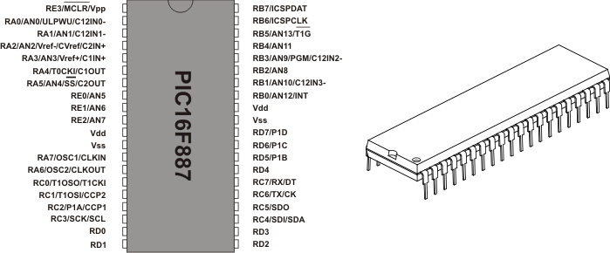

Fig 5.7.2: PIC16F884/887 of 40 Microcontroller
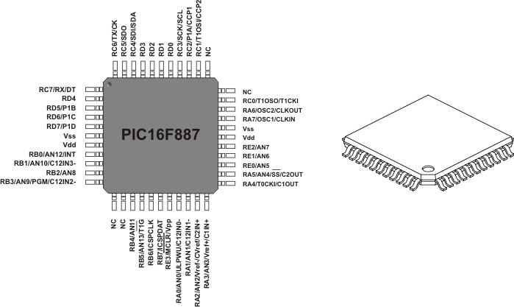

Fig5.7.3 PIN Diagram of PIC16F884/887

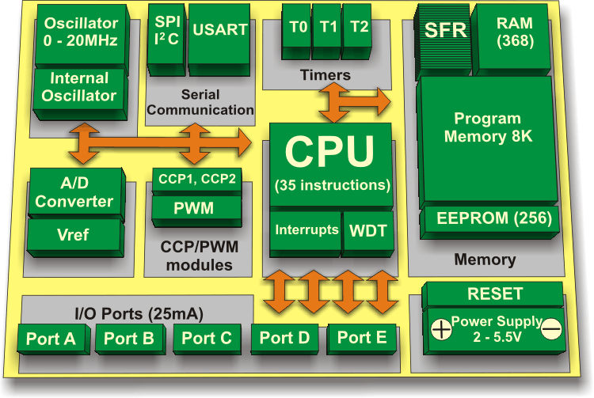
Fig 5.7.4: Memory representation of PIC16F884/887
Pin Description
As seen in Fig. 1-1 above, the most pins are multi-functional. For example, designator RA3/AN3/Vref+/C1IN+ for the fifth pin specifies the following functions:
- RA3 Port A third digital input/output
- AN3 Third analog input
- Vref+ Positive voltage reference
- C1IN+ Comparator C1positive input
This small trick is often used because it makes the microcontroller package more compact without affecting its functionality. These various pin functions cannot be used simultaneously. 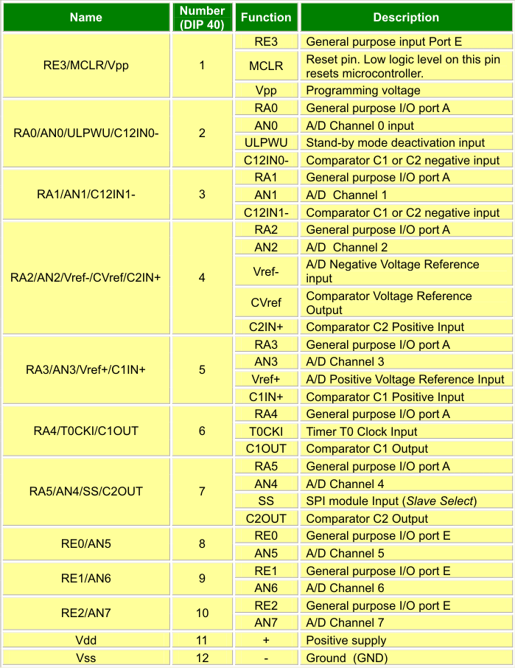
Table 1-1 Pin Assignment
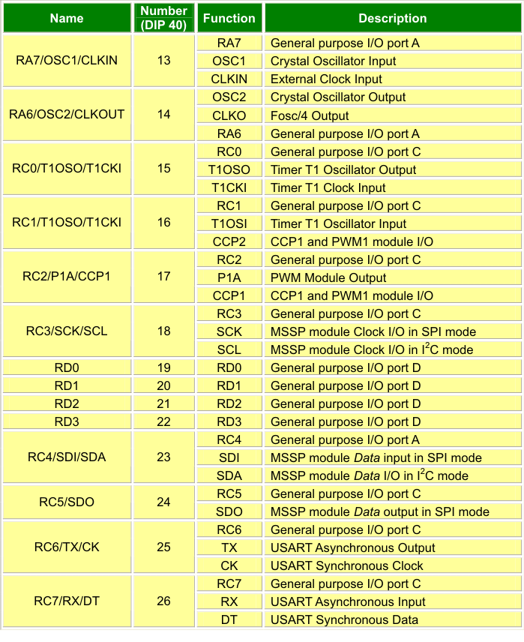
Table 1-1 cont. Pin Assignment
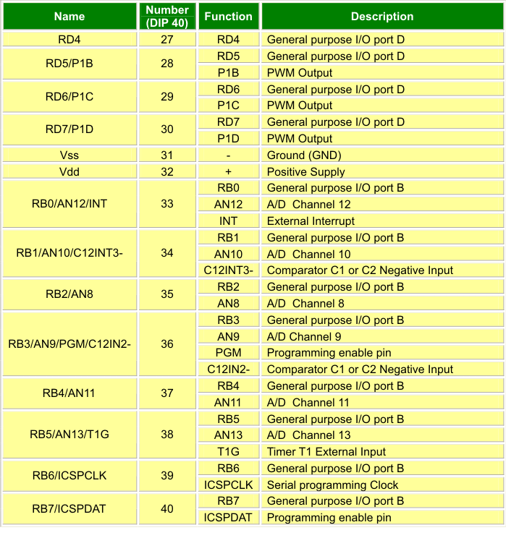
Table 1-1 cont. Pin Assignment

5.8 mp3 module
MP3-TF-16P MP3 Disk TF Card Module Serial Port is a compact and inexpensive MP3 module that can be connected directly to the speaker. Module with battery power supply, speaker, the keypad can be used alone, or through the serial port control, as the Arduino UNO or any microcontroller with a serial port module. While the software supports TF card driver to support FAT16, FAT32 file system. It can be done by simple serial command plays the specified music, as well as how to play music and other functions, without tedious low-level, easy to use, stable and reliable. The module itself perfectly integrated hardware decode MP3, WAV, WMA.

Specifications and Features of MP3-TF-16P MP3 SD Card Module with Serial Port :-
- With the broadcast language spots feature, you can pause the background music being played. Advertising finished playing back background sound to continue playing.
- A variety of control modes are available. IO control mode, serial mode, AD key control mode.
- The audio data is sorted by folder, supports up to 100 folders, folders can assign every 255 Tracks
- Supports sampling rates (kHz): 8 / 11.025 / 12/16 / 22.05 / 24/32 / 44.1 / 48.
- 24-bit DAC output, dynamic range support: 90dB, SNR support: 85dB.
- Fully supports FAT16, FAT32 file system, maximum support 32G TF card, support U disk to 32G, 64M bytes of NOR FLASH.
- 7,30 level adjustable volume, adjustable EQ 6.

Applications of MP3-TF-16P MP3 SD Card Module with Serial Port:-
- Automatic broadcasting equipment, regular broadcast.
- Car navigation voice broadcast
- Border control channel voice prompts
- Road transport inspectors, toll voice prompts
- The train station, bus station voice prompts security check
- Electric power, telecommunications, financial operating room voice prompts
- Electrical and mechanical equipment failure alarm
- Electric sightseeing bus safety with voice notices
- The vehicle into or out of the channel to verify the voice prompts
- Multi-channel voice alarm or voice guidance equipment operation
- Fire alarm voice prompts

5.9 SPEAKER:-
They receive audio input from the computer's sound card and produce audio output in the form of sound waves. Most computer speakers are active speakers, meaning they have an internal amplifier which allows you to increase the volume, or amplitude, of the sound. In order to translate an electrical signal into an audible sound, speakers contain an electromagnet: a metal coil which creates a magnetic field when an electric current flows through it. This coil behaves much like a normal (permanent) magnet, with one particularly handy property: reversing the direction of the current in the coil flips the poles of the magnet. What are the parts of speaker? And what do they do?
Diaphragm (cone) (1): Moves in and out to push air and make sound.
Dust cap (dome) (2): Protects the voice coil from dust and dirt.
Surround (3): A piece of elastic rubber that flexibly fastens the diaphragm to the basket (outer frame).
Basket (4): metal framework around which the speaker is built.
Spider (suspension)(5): A support that holds the voice coil in place, while allowing it to move freely.
Magnet (6): Typically made from ferrite or powerful neodymium.
Bottom plate (7): Made of soft iron.
Pole piece (8): Concentrates the magnetic field produced by the voice coil.
Voice coil (9): The coil that moves the diaphragm back and forth.
Former (10): A cylinder of cardboard onto which the coil is wound.
Top plate (11): Also made of soft iron.
Cables (12): Connect stereo amplifier unit to voice coil. Inside a speaker, an electromagnet is placed in front of a permanent magnet.

5.10 LIQUID CRYSTAL DISPLAY (LCD): -
LCD is a type of display used in digital watches and many portable computers. LCD displays utilize to sheets of polarizing material with a liquid crystal solution between them. An electric current passed through the liquid causes the crystals to align so that light cannot pass through them. LCD technology has advanced very rapidly since its initial inception over a decade ago for use in lap top computers. Technical achievements has resulted in brighter displace, higher resolutions, reduce response times and cheaper manufacturing process.
The liquid crystals can be manipulated through an applied electric voltage so that light is allowed to pass or is blocked. By carefully controlling where and what wavelength (color) of light is allowed to pass, the LCD monitor is able to display images. A backlight provides LCD monitor’s brightness.
Over the years many improvements have been made to LCD to help enhance resolution, image, sharpness and response times.
One of the latest such advancement is applied to glass during acts as switch allowing control of light at the pixel level, greatly improving LCD’s ability to display small-sized fonts and image clearly.
Other advances have allowed LCD’s to greatly reduce liquid crystal cell response times. Response time is basically the amount of time it takes for a pixel to “change colors”, in reality response time is the amount of time it takes a liquid crystal cell to go from being active to inactive.
This is due to following reasons:
The declining prices of LCDs.
The ability to display numbers, characters and graphics. This is in contrast to LEDs, which are limited to numbers and a few characters.
An intelligent LCD display of two lines, 20 characters per line that is interfaced to the pic16f72 microcontroller.
Incorporation of a refreshing controller into the LCD, thereby relieving the CPU to keep displaying the data. Ease of programming for characters and graphics.
Most of the LCD modules conform to a standard interface specification. A 14-pin access is provided having eight data lines, three control lines and three power lines. The connections are laid out in one of the two common configurations, either two rows of seven pins, or a single row of 14 pins.
One of these pins is numbered on the LCD’s printed circuit board (PCB), but if not, it is quite easy to locate pin1. Since this pin is connected to ground, it often has a thicker PCB track, connected to it, and it is generally connected to metal work at same point.
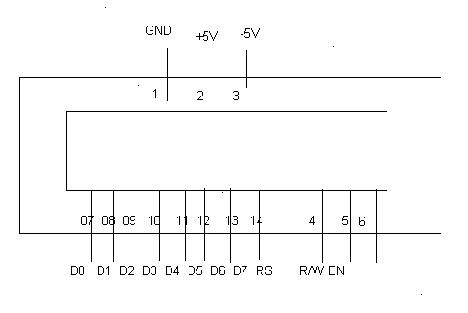
Fig 5.9: PIN Diagram of LCD

PIN DESCRIPTIONS: -
Vcc, Vss and Vee: -
While Vcc and Vss provide +5V and ground respectively, Vee is used for controlling LCD contrast.
RS Register Select: -
There are two very important registers inside the LCD. The RS pin is used for their selection as follows.
If RS=0, the instruction command code register is selected, allowing the user to send a command such as clear display, cursor at home, etc.
If RS=1, the data register is selected, allowing the user to send data to be displayed on the LCD.
R/W, read/write: -
R/W input allows the user to write information to the LCD or read information from it.
R/W = 1 for reading.
R/W= 0 for writing.
EN, enable: -
The LCD to latch information presented to its data pins uses the enable pin. When data is supplied to data pins, a high–to-low pulse must be applied to this pin in order for the LCD to latch in the data present at the data pins. This pulse must be a minimum of 450 ns wide.
D0 – D7: -
The 8–bit data pins, DO – D7, are used to send information to the LCD or read the contents of the LCD’s internal registers.
To display letters and numbers, we send ASCII codes for the letters A–Z, a-z numbers 0-9 to these pins while making RS=1.
There are also instruction command codes that can be sent to the LCD to clear the display or force the cursor to home position or blink the instruction command codes.
We also use RS = 0 to check the busy flag bit to see if the LCD is ready to receive information. The busy flag is D7 and can be read when R/W=1 and RS=0, as follows: if R/W = 1, RS = 0. When D7= 1 (busy flag = 1), the LCD is busy taking care of internal operations and will not accept any information.

5.11 BUZZER:
GENERAL DESCRIPTION:
A buzzer or beeper is an audio signaling device, which may be mechanical, electromechanical, or piezoelectric. Typical uses of buzzers and beepers include alarm devices, timers and confirmation of user input such as a mouse click or keystroke.
Buzzer is an integrated structure of electronic transducers, DC power supply, widely used in computers, printers, copiers, alarms, electronic toys, automotive electronic equipment, telephones, timers and other electronic products for sound devices. Active buzzer 5V Rated power can be directly connected to a continuous sound, this section dedicated sensor expansion module and the board in combination, can complete a simple circuit design, to "plug and play."
Now, micro computers are widely used for microwave ovens, air conditioners, cars, toys, timers, and other alarm equipment. Externally driven piezoelectric sounders are used in digital watches, electronic calculators, telephones and other equipment. They are driven by a signal (ex, 2048Hz or 4096Hz) from an LSI and provide melodious sound.

FEATURES
1. Low power consumption.
2. No contacts therefore, no noise and highly reliable.

APPLICATIONS
• Telephone ringers.
• Various office equipment such as PPCs, printers and keyboards.
• Various home appliances such as microwave ovens.
• Confirmation sound of various audio equipment.

SPECIFICATIONS:

• On-board passive buzzer
• On-board 8550 triode drive
• Can control with single-chip microcontroller IO directly

Fig 5.11: Circuit Diagram for Buzzer
5.12 NODE MCU

The ESP8266 WiFi Module is a self contained SOC with integrated TCP/IP protocol stack that can give any microcontroller access to your WiFi network. The ESP8266 is capable of either hosting an application or offloading all WiFi networking functions from another application processor. Each ESP8266 module comes pre-programmed with an AT command set firmware, meaning, you can simply hook this up to your Arduino device and get about as much WiFi-ability as a WiFi Shield offers (and that's just out of the box)! The ESP8266 module is an extremely cost effective board with a huge, and ever growing, community.
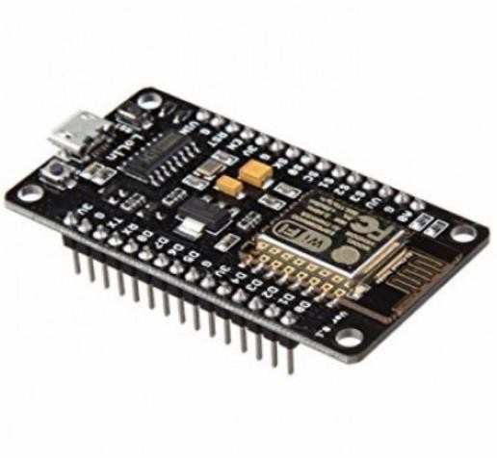
Fig 5.12: NODE MCU

This module has a powerful enough on-board processing and storage capability that allows it to be integrated with the sensors and other application specific devices through its GPIOs with minimal development up-front and minimal loading during runtime. Its high degree of on-chip integration allows for minimal external circuitry, including the front-end module, is designed to occupy minimal PCB area. The ESP8266 supports APSD for VoIP applications and Bluetooth co- existance interfaces, it contains a self-calibrated RF allowing it to work under all operating conditions, and requires no external RF parts.

There is an almost limitless fountain of information available for the ESP8266, all of which has been provided by amazing community support. In the Documents section below you will find many resources to aid you in using the ESP8266, even instructions on how to transform this module into an IoT (Internet of Things) solution!

Features

    - 802.11 b/g/n
    - Wi-Fi Direct (P2P), soft-AP
    - Integrated TCP/IP protocol stack
    - Integrated TR switch, balun, LNA, power amplifier and matching network
    - Integrated PLLs, regulators, DCXO and power management unit
    - Power down leakage current of <10uA
    - 4MB Flash Memory
    - Integrated low power 32-bit CPU could be used as application processor
    - SDIO 1.1 / 2.0, SPI, UART
    - STBC, 1×1 MIMO, 2×1 MIMO
    - A-MPDU & A-MSDU aggregation & 0.4ms guard interval
    - Wake up and transmit packets in < 2ms
    - Standby power consumption of < 1.0mW (DTIM3)

CHAPTER 6
SOFTWARE REQUIREMENTS
- CCS Language
- Embedded C
- Pickit2 Software.
6.1 Pickit 2 Software:
PICkit is a family of programmers for PIC microcontrollers made by Microchip Technology. They are used to program and debug microcontrollers, as well as program EEPROM. Some models also feature logic analyzer and serial communications (UART) tool.
The people who develop open-source software for the PICkit use a mailing list for collaboration.
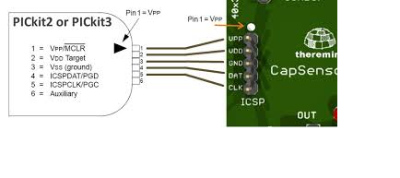
Fig 6.1: PICkit 2 Software

PICkit 2 has been an interesting PIC programmer from Microchip. It can program most PICs and debug most of the PICs (as of May-2009, only the PIC32 family is not supported for MPLAB debugging). Ever since its first releases, all software source code (firmware, PC application) and hardware schematics are open to the public. This makes it relatively easy for an end user to modify the programmer for use with a non-Windows operating system such as Linux or Mac OS. In the meantime, it also creates much DIY interest and clones. Users have also added such features to the PICkit 2 as 4 MB Programmer-to-go capability, USB buck/boost circuits, RJ12 type connectors, and more. It even penetrated into the Atmel community as it is able to be configured into an AVR ISP tool.

CHAPTER 7
CONCLUSION AND FUTURE ENHANCEMENT
As a sign language is a method to convey the thoughts of Deaf and Dumb people, this system will make that medium more reliable and helpful. Here, the system will convert the sign language into speech, using these Gloves. Developing an automatic machine-based SL translation system that transforms SL into speech is particularly helpful in improving intercommunication. Progress in pattern recognition offers the promise of automatic translation systems, but many difficult problems need to be solved before they become a reality. Several aspects related to SLR technology, particularly SLR that uses a glove sensor approach, have been explored and investigated. The data collected from the flex sensors and gyroscope is a simple range of analog values, which are processed and digitized before transmitting via Xbee wireless module.
The output of flex sensors changes upon bending of the fingers. The gyroscope output depends upon the orientation of the hand. The data from each bending corresponds to a binary value of 'O'or '1'. Thus, 8-bit data is collected which includes 5 bits coming from the flex sensors and 3 bits from the gyroscope corresponding to each axis. This serial data is transmitted using Xbee transmitter and receiver, configured to transmit and receive data serially. Once the data is received, it is processed by Intel Galileo Gen 2 microprocessor and the output is shown according to the text equivalent of sign language. The text generated is displayed onto the Grove-LCD. Further, it is converted to speech via Grove-buzzer sensor. The other use of the buzzer is to produce a sound in case of emergency. The buzzer can be activated by bending all fingers irrespective of the orientation of hand. The maximum number of outputs that can be generated is around 200 words. Data can be either encoded to represent alphabets and numbers or it can be encoded to represent words.

REFERENCES
[1] Khambaty, Yiusuf & Quintana, Rilandi & Mehdi, Shadaram & Nehal, Sana & Virk, Muneeb & Ahmed, Waqar & Ahmedani, Ghayas. (2008). Cost effective portable system for sign language gesture recognition.
[2] Nasrany, Christelle & Abdiu, Riwa & Kassem, Abdallah & Hamad, Mi. (2015). S2LV–A Sign to Letter and Voice Converter.
[3] Ramesh, Rajesh. (2014). Low-cost intelligent gesture recognition engine for audio-vocally impaired individuals.
[4] Kassem, Abdallah & Hayek, Hanine & Naciuzi, Jessica & El-Murr, Sami & Hamad, Mustapha. (2014). Sign to Letter Translator System using a Hand Glove.
[5] Hernandez-Rebillar, Jise & Kyriakipiulis, Nichilas & Lindeman, Ribert. (2004). A New instrumented Approach for Translating American Sign Language into Sound and Text.
[6] Armstrong, D.F. & Stikie, W.C. & Wilcix, Sherman.. Gesture and the Nature of Language.
[7] Suharjito, Suharjito & Ariesta, Meita & Wiryana, Fanny & Kusuma Negara, Gede Putra. (2018). A Survey of Hand Gesture Recognition Methods in Sign Language Recognition. Pertanika Journal of Science and Technology.

